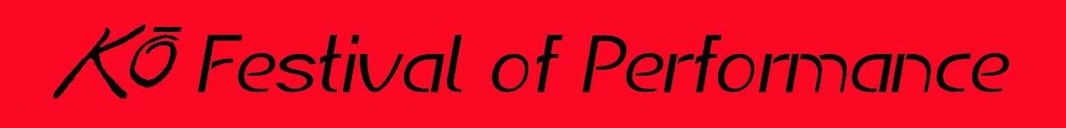

2019 KOFEST PROGRAM AD AGREEMENT &
INVOICE
Date: _________________________ Name of KoFest Contact: _____________________________________
Name of Advertiser: _______________________________________________________________________
Mailing/Street Address: ____________________________________________________________________
Website URL: ____________________________________________________________________________
Contact Person Name: _____________________________________________________________________
Land Phone: ______________________________Cell Phone: _____________________________________
E-mail: _________________________________________________________________________________
Please check desired ad size:
Size chosen | Ad Size | Dimensions | Cost
 | 1/4 page (Business card size) | 3 ½”w x 2”h | $89
 | 1/3 page | 5”w x 2.5”h | $119
 | 1/2 page | 5”w x 4”h | $159
 | Full page | 5”w x 8”h | $249
 | Back / Inside Cover or Centerfold | 5”w x 8”h | $425

Reservations are due by June 28 and camera-ready ad copy is due by July 1. If we are going to be designing or updating an ad for you, that copy is due June 24.
* Please note that we must add a 10% surcharge for ads not paid in full by 7/30/19.
If you have questions, please email ezzellfloranina@gmail.com. You may also call her at 413-219-5546
Checks should be made out to: “Ko Theater Works, Inc.” and mailed to PO Box 137, Amherst, MA 01004. You can also arrange for pickup by contacting Ezzell at ezzellfloranina@gmail.com.
Advertiser Signature _____________________________________ Title: _____________________________
Print Name: ___________________________________________ Date: _____________________________
For more on the season visit www.kofest.com.
**Please note this form can be used as both your order and your invoice.**

